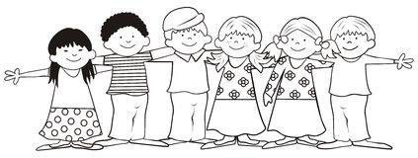
Friends First

Disabilities Awareness Coloring Book

This is Bobby. Bobby loves his dog, Scooter. Bobby can’t walk so he uses his special wheel power to go on walks with scooter.

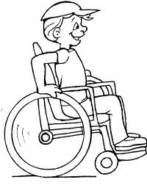

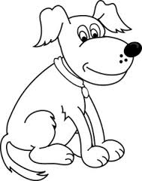

Bobby and Scooter like to walk to his friend, Caleb’s house. At Caleb’s house, they all play ball together.
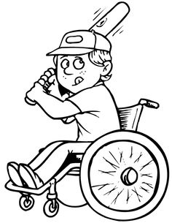

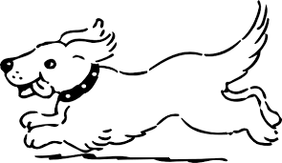
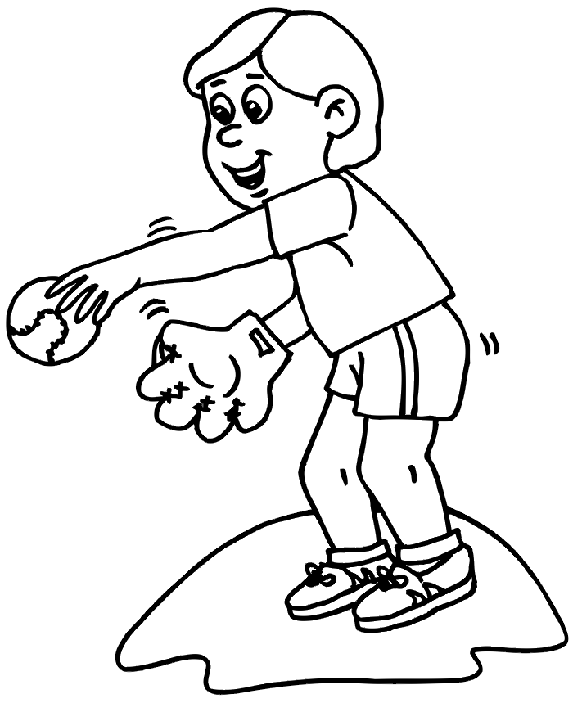

This is Caitlyn. Caitlyn loves Cheerleading. She must be very careful at practice because she can’t hear things.

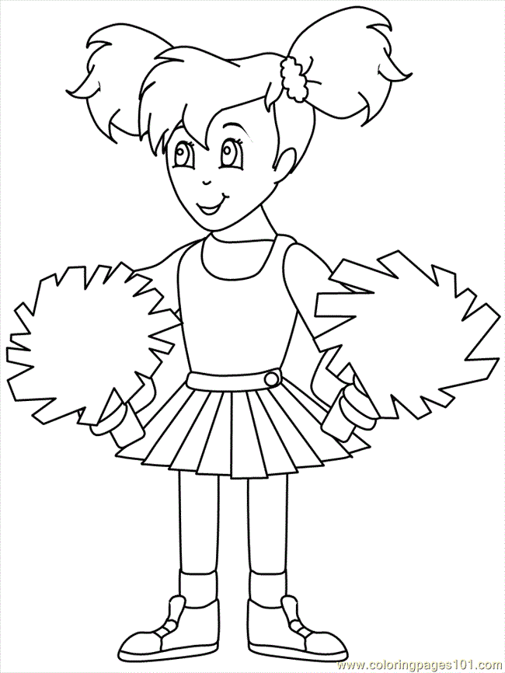

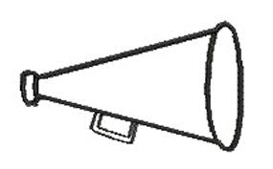

Caitlyn is deaf. She talks with her hands in sign language. The rest of the cheerleaders learn sign language to talk to Caitlyn. Here are some of the signs Caitlyn uses.

Can you spell your name for Caitlyn?

